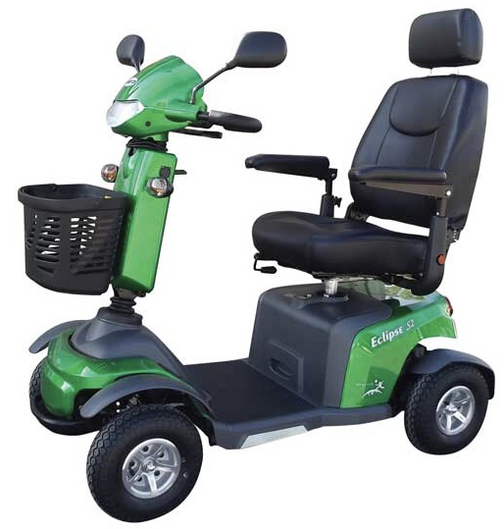



**ECLIPSE S2**

